Antibiotic usage data in pigs from the electronic Medicines Book (eMB): 2025

Scope and limitations of the data
- These data are national, aggregated figures for antibiotic usage calculated from individual unit data held in the eMB for pig farms across the UK. eMB uptake to date has been voluntary and this sample may not be representative for the whole of the UK

- In terms of UK pig production, these eMB data cover over 96% of slaughter pigs for 2024. As in previous years, UK clean pig slaughter data are sourced from Defra and the Department of Agriculture, Environment and Rural Affairs (Daera). We regularly review this measure of coverage to ensure it continues to be appropriate

- The data are inputted by producers, and although clear outliers have been identified and queried, AHDB is not able to validate every individual producer’s data. However, at a national, aggregated level, the data provide an estimation of national usage and allow year-on-year comparisons to be made

- These data were extracted from eMB on 29 May 2025, and these figures will now be fixed as the reference levels for 2024. Producers may still add 2024 data to eMB for their own usage, but data entered or modified after this date will not be used to further amend the national aggregated figures

- The eMB database and the calculations within it are regularly subjected to a series of quality assurance checks to ensure national aggregated figures are as accurate as possible. As a result of this process, the eMB system is continuing to develop and work to further improve data accuracy is ongoing

- The calculations used for the eMB data are in line with the methods used by the European Surveillance of Veterinary Antimicrobial Consumption (ESVAC) project to allow comparisons to be made with European counterparts

Table 1. Name, title and dated signature of report authors
Role | Name and title | Signature | Date
Prepared by | Jennifer Newman  Lead Livestock Science Data Specialist |  | 1 May 2026
Reviewed by | Mandy Nevel  Head of Animal Health and Welfare |  | 1 May 2026
Approved by | Mark Haighton  Pork Sector Director |  | 13 May 2026

Total antibiotic usage recorded in eMB

Total antibiotic usage in pigs for 2025 was 77.2 mg/PCU (milligrams per population correction unit).

This is a decrease of 10% from 86.2 mg/PCU in 2024 and represents a 72% reduction in antibiotic use since the 2015 baseline.

Table 2. Annual milligrams per population correction unit from 2015 to 2025 and the year-on-year percentage change

Year | mg/PCU | Year-on-year change (%)
2015 | 277.7 | No data available
2016 | 182.7 | −34
2017 | 130.7 | −28
2018 | 110.1 | −16
2019 | 110.5 | 0
2020 | 105.0 | −5
2021 | 87.4 | −17
2022 | 71.8 | −18
2023 | 84.8 | +18
2024 | 86.2 | +1
2025 | 77.2 | −10

Figure 1. Bar chart of total antibiotic use recorded in eMB with annual target line 2015–2028 (mg/PCU)
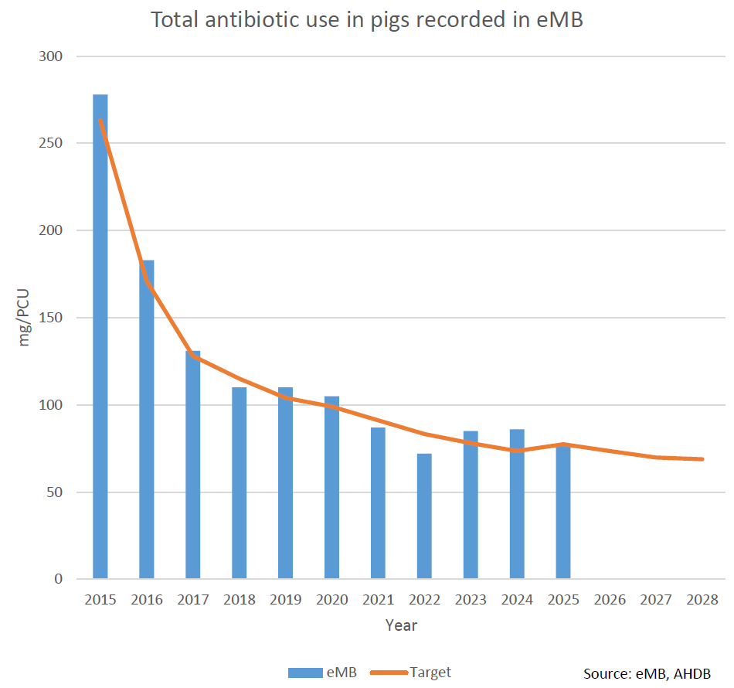

Source: eMB, AHDB

Highest priority critically important antibiotic (HP-CIA) usage recorded in eMB

Use of highest priority critically important antibiotics (HP-CIAs) remains at a very low level; a slight increase from 0.009 mg/PCU to 0.012 mg/PCU has been recorded in 2025. No colistin use has been reported in pigs in 2025.

The HP-CIAs include colistin, third- and fourth-generation cephalosporins and fluoroquinolones, as defined by the World Health Organization (WHO) and aligns to the European Medicines Agency Category B (‘restrict’).

Table 3. Annual usage of HP-CIAs from 2015 to 2025 and the amount of colistin in milligrams per population correction unit

Year | HP-CIAs (mg/PCU) | Colistin (mg/PCU)
2015 | 1 | 0.9
2016 | 0.3 | 0.2
2017 | 0.1 | 0.012
2018 | 0.06 | 0.004
2019 | 0.04 | 0.002
2020 | 0.052 | 0
2021 | 0.033 | 0
2022 | 0.013 | 0
2023 | 0.007 | 0
2024 | 0.009 | 0
2025 | 0.012 | 0

Figure 2. Bar chart of annual usage of HP-CIAs in pigs recorded in eMB from 2015 to 2025 (mg/PCU)

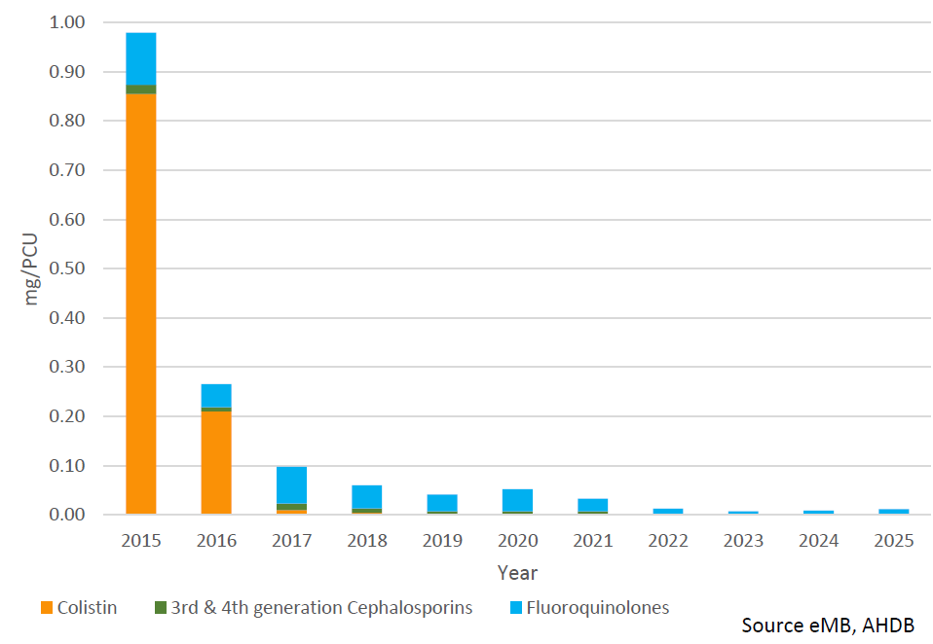

Source: eMB, AHDB

Antibiotic usage recorded in eMB by antibiotic class

Most classes of antibiotic have shown reduced use compared to 2024. The largest reduction has been seen in tetracyclines, with a decrease of 4.5mg/PCU.

Trimethoprim-sulphonamides, aminoglycosides and broad-spectrum penicillins have each reduced by between 1 and 2 mg/PCU.

Small increases have been recorded in amphenicols (0.2mg/PCU) and pleuromutilins (0.9mg/PCU).

Figure 3. Pie chart of 2025 antibiotic usage in pigs recorded in eMB by class

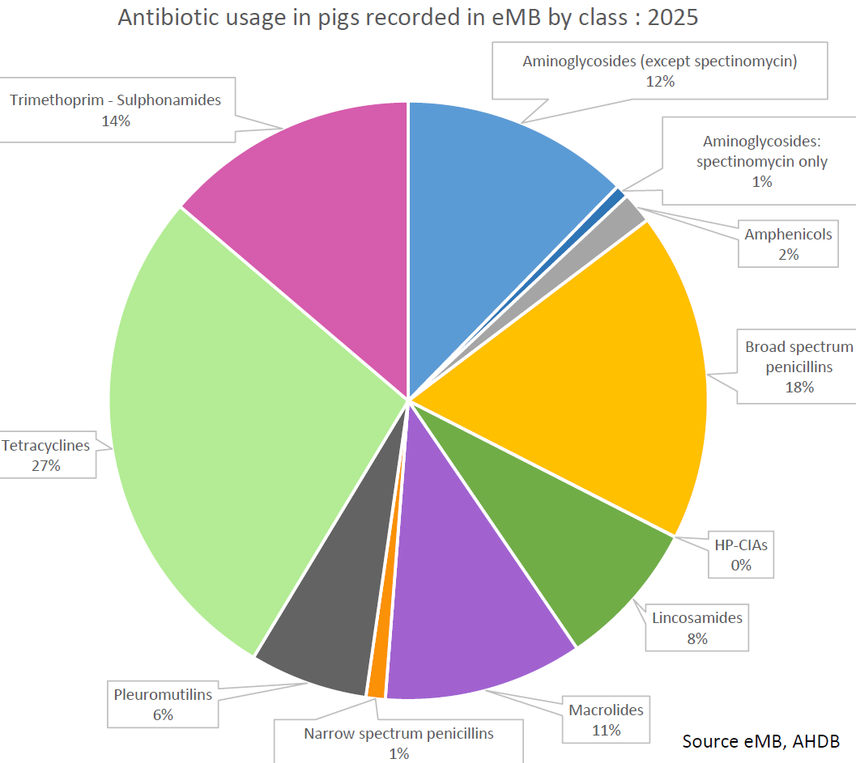

Source: eMB, AHDB

The HP-CIAs segment accounts for 0.01% of all antibiotics used in pigs in 2025 (Figure 3).

Contact us
AHDB, Siskin Parkway East, Middlemarch Business Park, Coventry CV3 4PE
Email: info@ahdb.org.uk

